**Exercises**

In these exercises, you’ll use the MySQL Workbench to review the tables in the AP database. In addition, you’ll use the MySQL Workbench to enter SQL statements and run them against these tables.

**Make sure the MySQL server is running**

1. Start MySQL Workbench and open a connection for the root user.
2. Check whether the MySQL server is running. If it isn’t, start it. When you’re done, close the Startup/Shutdown window.

**Use MySQL Workbench to review the Accounts Payable (AP) database**

1. In the Navigator window, expand the node for the AP database so you can see all of the database objects it contains.
2. View the data for the Vendors and Invoices tables.
3. Navigate through the database objects and view the column definitions for at least the Vendors and Invoices tables.

(See below for my screenshots)

Viewing data from invoices: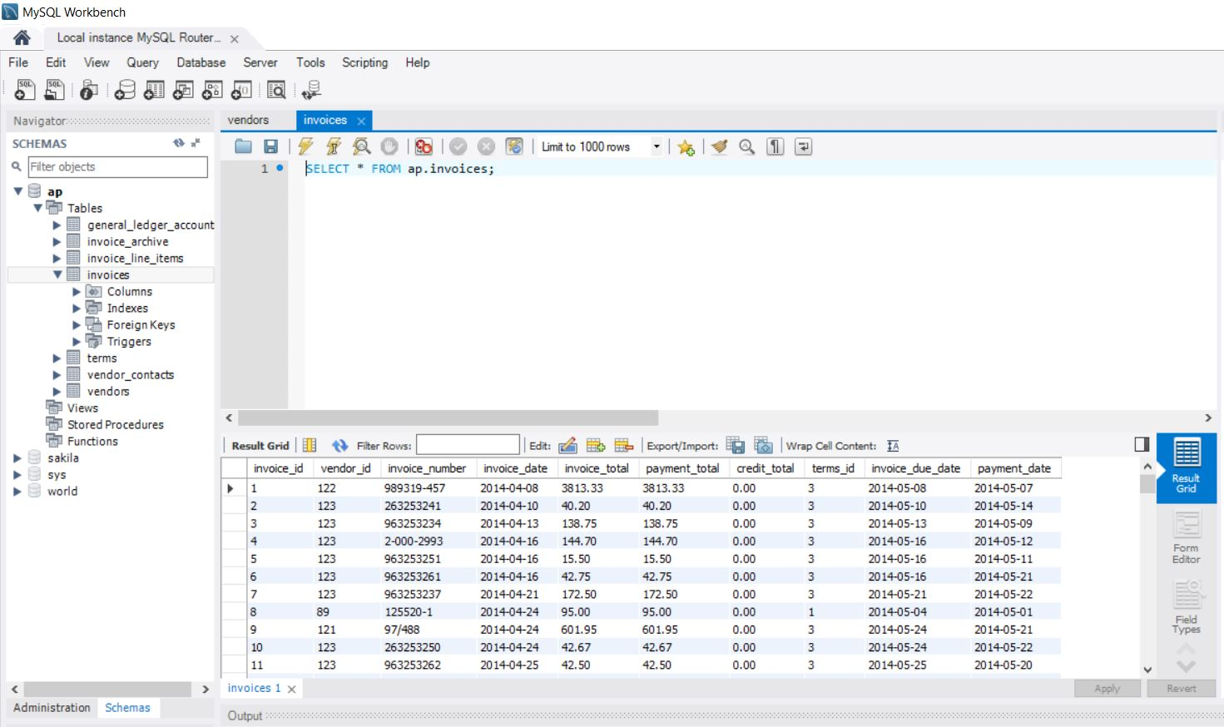

Viewing data from vendors: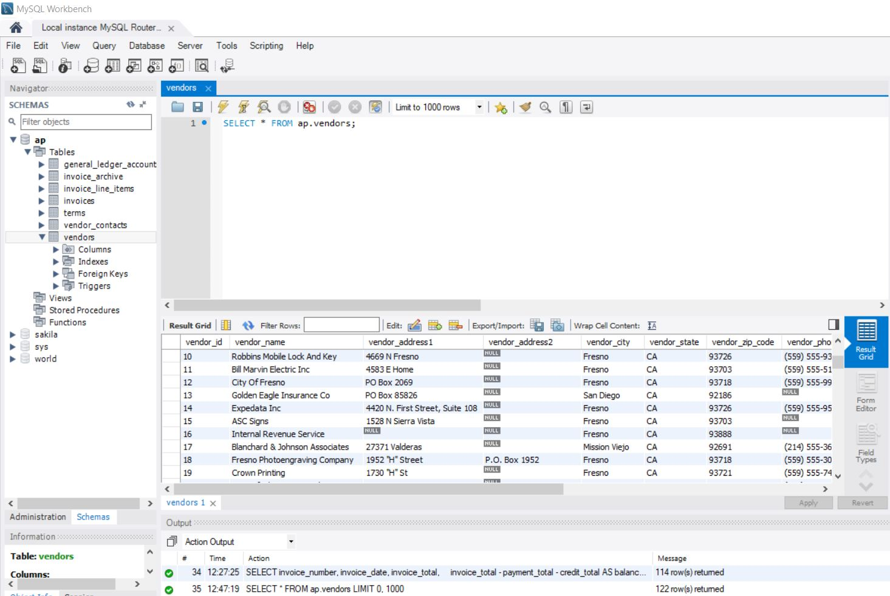

**Use MySQL Workbench to enter and run SQL statements**

1. Double-click the AP database to select it. When you do that, MySQL Workbench should display the database in bold.
2. Open a SQL Editor tab. Then, enter and run this SQL statement:
   1. SELECT vendor_name FROM vendors
3. Delete the e at the end of vendor_name and run the statement again. Note the error number and the description of the error.
4. Open a SQL Editor tab. Then, enter and run this statement:
   1. SELECT COUNT(*) AS number_of_invoices
      1. SUM(invoice_total) AS grand_invoice_total
   2. FROM invoices

Running vendor_name: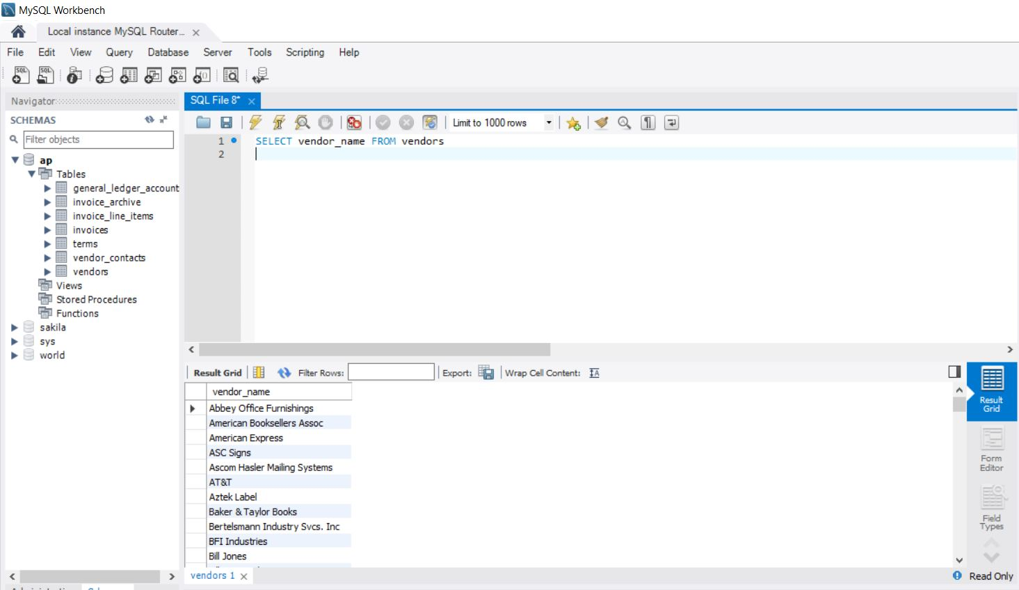

Running vendor_nam and getting error: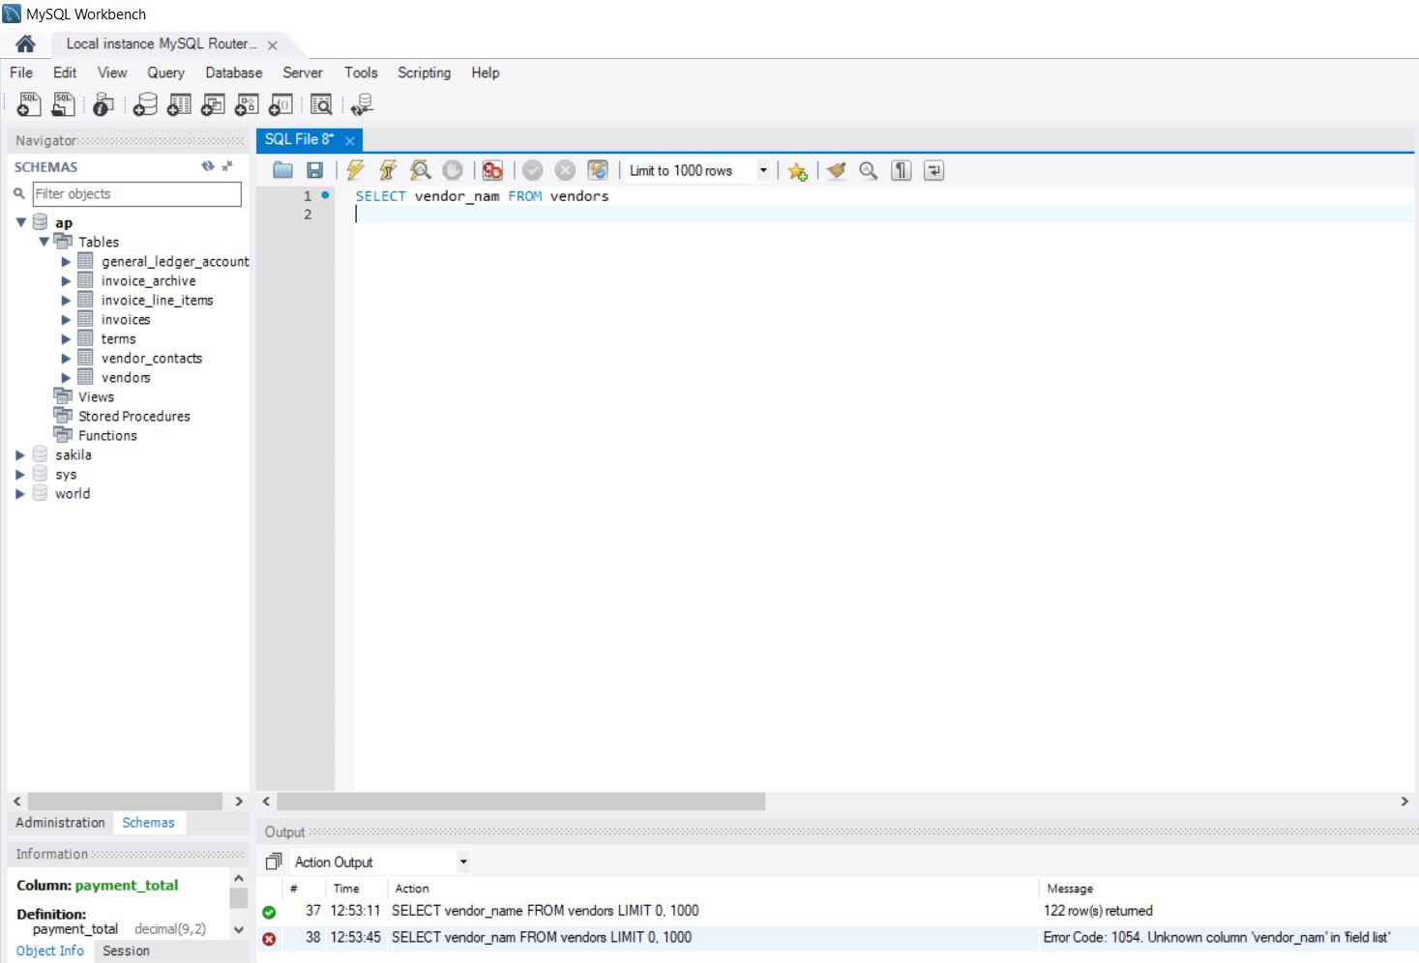

Running script to get grand_invoice_total: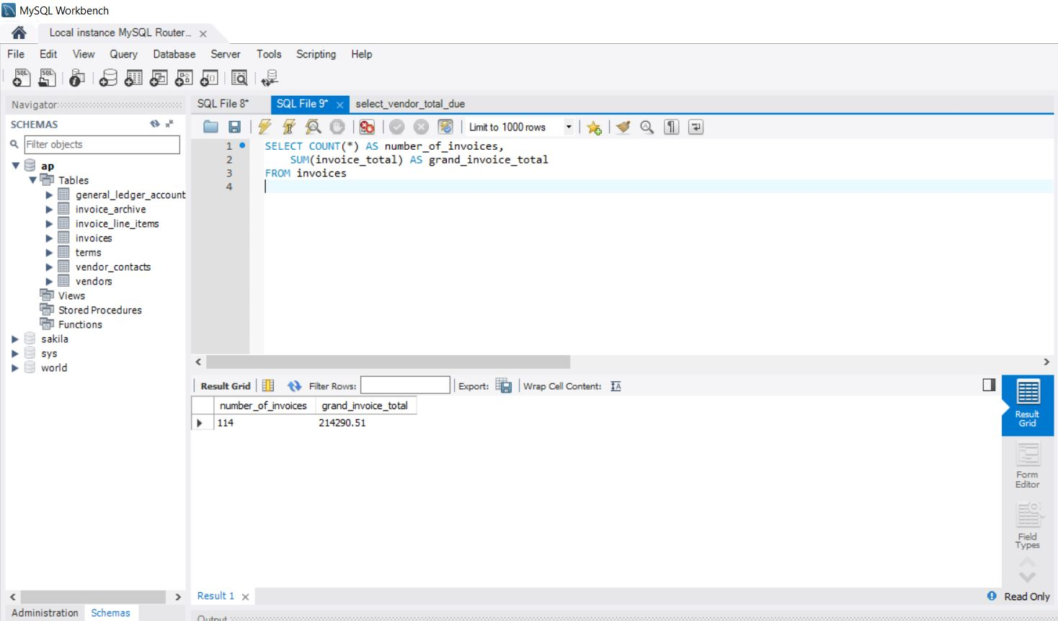

**Use MySQL Workbench to open and run scripts**

1. Open the select_vendor_city_state script that’s in the c:\murach\mysql\scripts\ch02 directory. Note that this script contains just one SQL statement. Then, run the statement.
2. Open the select_vendor_total_due script that’s in the ch02 directory. Note that this opens another SQL Editor tab.
3. Open the select_vendor_information script that’s in the ch02 directory. Notice that this script contains two SQL statements that end with semicolons (scroll down if you need to).
4. Press the Ctrl+Shift+Enter keys or click the Execute SQL Script button to run both of the statements in this script. Note that this displays the results in two Result grids. Make sure to view the results of both SELECT statements.
5. Move the insertion point into the first statement and press Ctrl+Enter to run just that statement.
6. Exit from MySQL Workbench.

(See below for my screenshots)

Running first script only: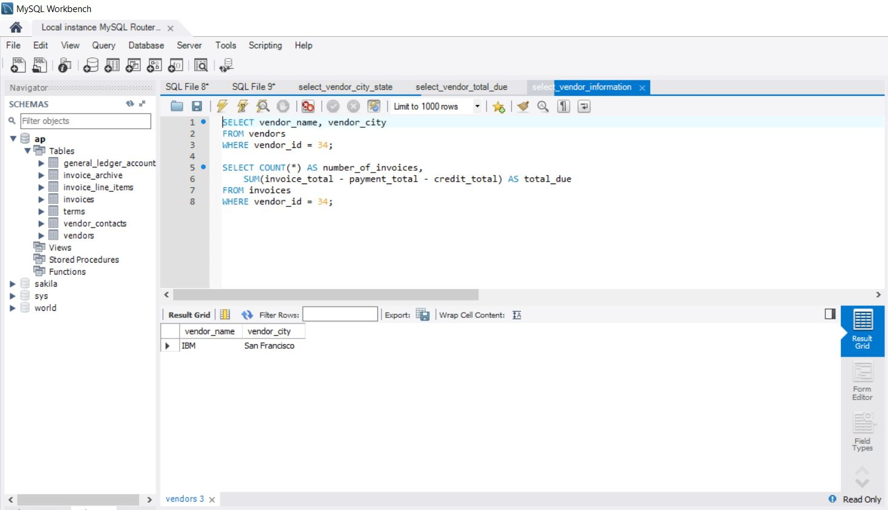

Running second script only: